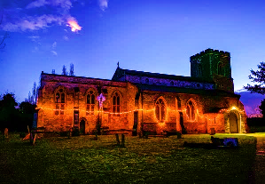
St Peter and St Paul’s Dry Drayton
A small church with a big heart

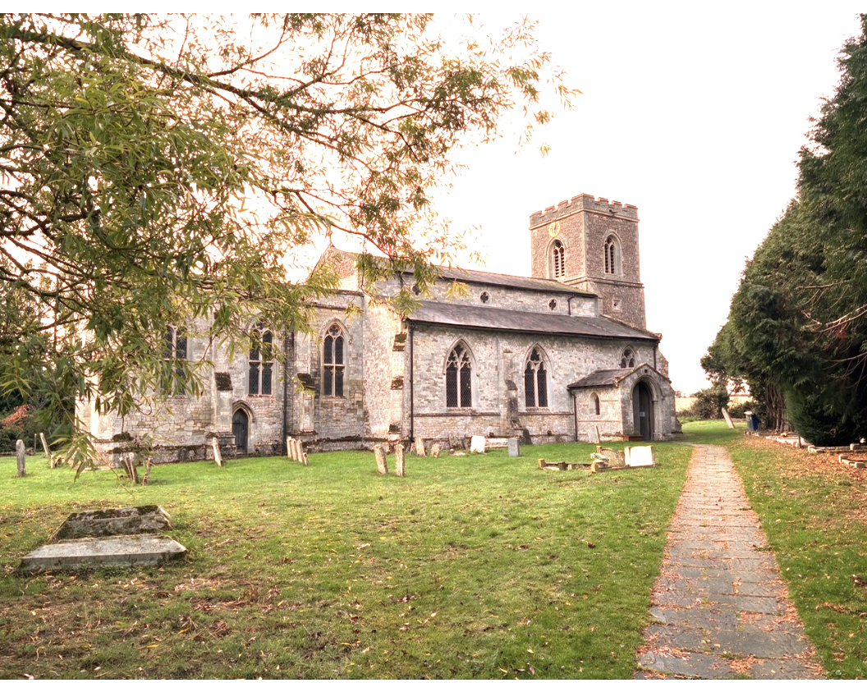
Newsletter October 2026
Dear Friends,
What would a world without forgiveness look like? Be like? Let's imagine for a few moments what it would be like to live in such a world. An unforgiving world is not God like. There would be many angry moments, some potentially violent. It would foster dishonesty and lying. It would lead to putting up dividing walls between people which are permanent. The wonder of forgiveness is that it opens doors to healing and reconciliation. It's not that those who choose to forgive forget, but they choose not to yield to the same destructive forces of revenge and retribution. God's forgiveness surpasses both our deserving and comprehension of it, and therefore the appropriate response is always to forgive, because God always forgives us everything. Of course, forgiveness doesn't mean that we stand by while evil things happen. If we become aware of a serious and ongoing crime or situation like domestic abuse or human trafficking or domestic slavery, then we have to act and inform the authorities. Forgiveness is balanced with our duty to protect the vulnerable from bad people. Keeping people safe and being a safe space as a church community for everyone is fundamental to our Christian calling and way of life. We must always call out wrongdoing and take appropriate action when we witness or learn about something that is seriously wrong. When Jesus commands us to forgive he is not talking about ignoring evil or wrongdoing. Jesus stood up for the vulnerable and oppressed and called out evil for what it was. Jesus was a big champion for fighting evil. He didn't tolerate it. Yet he was a proponent of forgiveness and turning the other cheek, not least on the cross. He is talking about a frame of mind or an attitude where we don't carry grudges. Where we try and give others another chance. Where we love them enough to forgive. Ultimately, Jesus teaches us that God will judge all things and all people in the end. By forgiving and not carrying grudges and anger, we can feel God's peace because we are freed while they're imprisoned by the things done to us. When we choose to forgive, then we are choosing Jesus's way, the way of love, which can completely transform us and our lives.
God Bless,
Clare
Revd Clare Coates
Team Rector of the Lordsbridge Team
Lead Minister for Dry Drayton, Caldecote with Childerley and Hardwick
clarecoates@lordsbridge.org
07818 618 795
https://drydraytonchurch.co.uk/

October Services
Sunday 4 October
5:30pm Choral Evensong with Revd Clare
Sunday 11 October
11am Harvest Festival with Revd Clare. We will be collecting gifts for the Foodbank.
Sunday 18 October
11am Sung Holy Communion with Revd Lynda
Sunday 25 October
10:30am Holy Communion LordsbridgeTeam service at St Peter and St Paul’s Dry Drayton with Revd Clare
Online Services

Sundays at 11am Lordsbridge Zoom Service
Join Zoom Meeting
https://us02web.zoom.us/j/88221400075?pwd=b3VQeDArQVJRREtYTlgrZ0tEbDdWdz09
Meeting ID: 882 2140 0075
Passcode: 534531

Weekday Services:
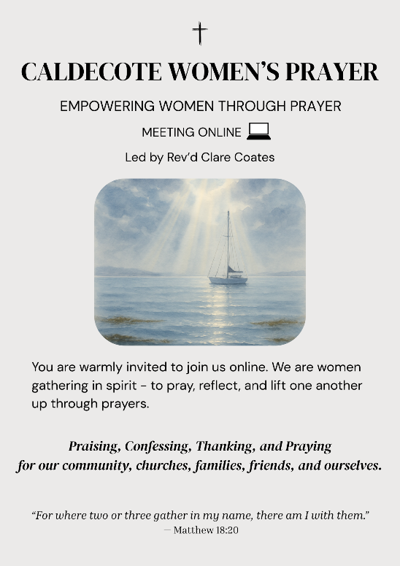
Caldecote Women’s Prayer group Thursday mornings in term time at 9am on Zoom Women from Caldecote and surrounding villages are warmly invited to join us online, gathering in spirit to pray, reflect and lift one another up through prayers. https://us02web.zoom.us/j/88137270141?pwd=pCvjk7eQrFqYX8GrvRP6JmMZKI9bYK.1
Meeting ID: 881 3727 0141
Passcode: 655934
Friday night prayers at 7:30pm, on Zoom with ALM Micheala McNeill
All most welcome to join us on Fridays for night prayers starting at 7.30 pm with chat and prayer actually beginning at 7.45 pm: https://us02web.zoom.us/j/83806423658?pwd=Ux2yZaz0VJeLnNbF12pUyuvihUeSkL.1
Meeting ID: 838 0642 3658
Passcode: 167011
What’s On:
Dry Drayton Coffee Morning
First Wednesdays every month, in the Village Hall, 10am -12noon.

HARDWICK Saturday 17 October
The Big Book sale at the Cabin 10-4pm! Lots of great books to choose from and refreshments served all day.
Sunday 18 October at St Peter and St Paul’s Dry Drayton

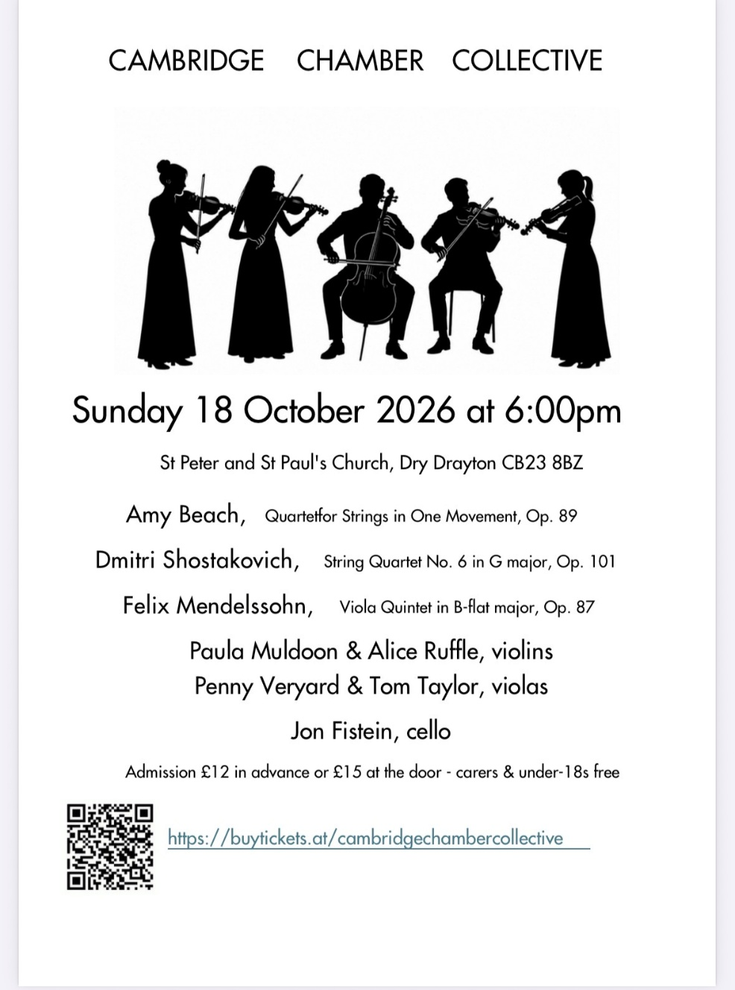

Saturday 24 October 10-12 at the Cabin in Hardwick:
Rooted: Discovering Ways to pray with Revd Clare Coates and Revd Steve Clark
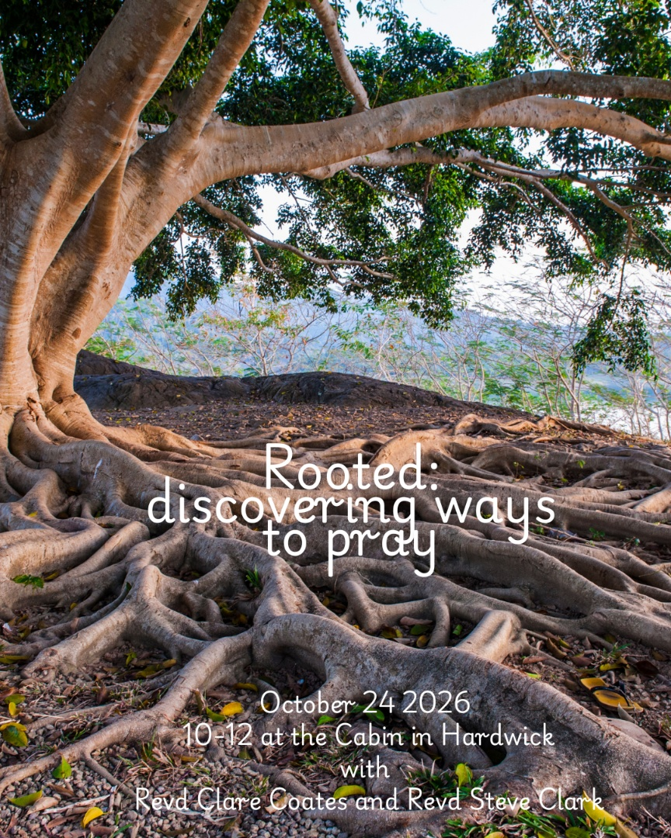
Are you a regular intercessor at your Church? Or would you like to try leading prayers? Would you like to find out more about prayer, and why we pray?
Prayer is at the heart of our lives and work as Christians and as a Team. We believe God is calling us to a deeper commitment to prayer and we are expectant that God is at work in us as we seek Him together. We believe that prayer is more than something we ‘do.’ Let’s plant firm roots in God as we pray together and as we seek to draw closer to Him together.
All are very welcome to join us for a morning workshop, focusing on discovering the many different ways we can pray, and finding your own voice as you pray.

Community
HARDWICK Tuesday Toddlers in the Cabin 10-11:30am, every Tuesday in term time.
All welcome to join us for free play, craft, story and fun!

.

Useful contacts
Lordsbridge Team:
Revd Claire Robertson, Lead Minister for Coton, Barton, Harlton and Haslingfield: 01223 874194; clairerobertson@lordsbridge.org
Revd Charles Fraser, Lead Minister for Little and Great Eversden: charlesfraser@lordsbridge.org; 01223 264974
Team Administrator: Mrs Sue Squire: thelordsbridgeteam@gmail.com
Lordsbridge Team Instagram: @lordsbridge_team
Lordsbridge Team Facebook Page: https://www.facebook.com/LordsbridgeTeam

