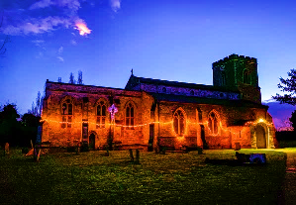
St Peter and St Paul’s Dry Drayton
A small church with a big heart

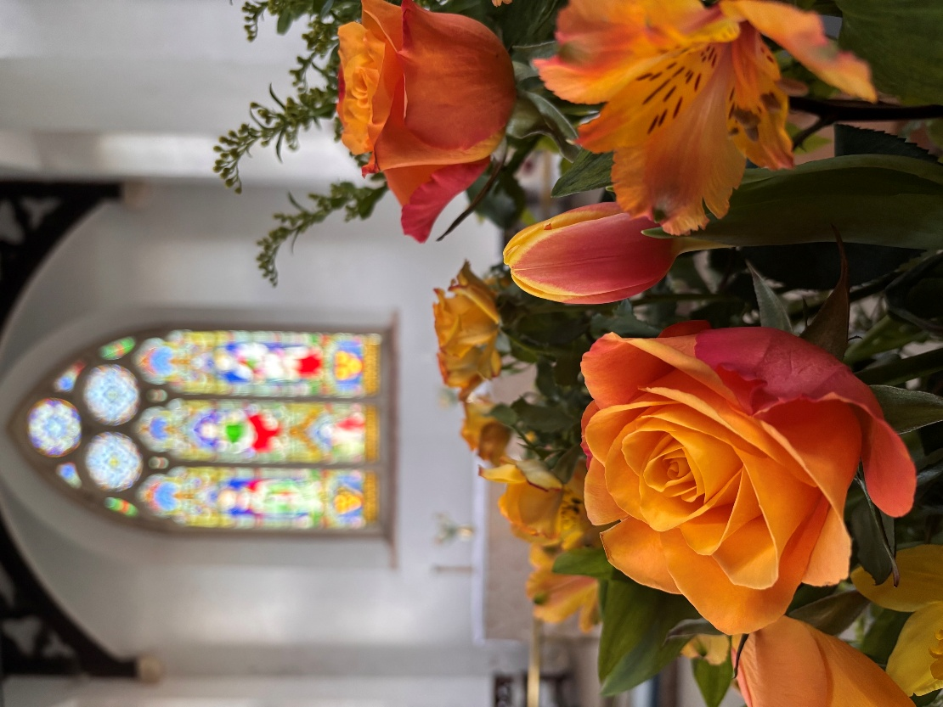
Newsletter June 2026
Dear Friends,
I really enjoyed this year's Lordsbridge pilgrimage. What I particularly liked was that we didn't rush but took our time. Whether it was on Red Meadow Hill; in the fields between Coton and Hardwick; in the wonderful coolness of Hardwick wood (in Caldecote parish!); or on the last leg between Childerley and Dry Drayton: it was good to stop. Listen. And see so much beauty. We saw some fantastic birds – red kites; buzzards; yellow hammers and even a cuckoo in flight! Lots of little butterflies and moths. Fields of glorious buttercups and daisies, a riot of yellow and white. Stunning wildflowers. And of course many trees, which provided welcome shade for us pilgrims. We live in such a beautiful place!
As I was walking through the beautiful countryside I was reminded of a reading from 1 Corinthians 3 where Paul uses field imagery to illustrate a very important point about God's Kingdom. At the heart of this passage is a very strong message: that we are called to work together for God, acknowledging and trusting that it is God who gives the growth (v6). God calls all kinds of people - like you and me - all with different backgrounds, perspectives, experience, views, and understanding. We're not all the same! But God places us together to work for Him, building His Kingdom together. In writing to the Corinthians, Paul was trying to encourage teamwork and to bring together the many different voices which made up the church community in Corinth. And most of all, to emphasise that everyone has a part to play. This is a very important lesson for us because it teaches us that the church community is stronger when everyone brings their different perspectives, experience and talents to help spread the good news where we live.
There is something very spiritual and very inspiring in Paul's choice of a field metaphor to illustrate the way in which we all have a part to play working for God together. Paul’s image of a field is a good reminder to us that we depend entirely on God for everything. That we need to put ourselves into God's hands. To intentionally make time for God in our lives. Maybe to be like a field? Not rush but just be. When we look at a field, we can see it's growing organically. It's full of vitality, energy and life. Green shoots of growth appearing in their own time. Seeds spreading and pollinating, especially at this time of year. Fields are ever changing and evolving. Many other great thinkers and artists throughout history have also seen fields as having a deep spiritual quality. Vincent Van Gough, for example, spent his whole life trying to capture in his paintings the spiritual quality of fields and plants because he strongly felt God's presence in nature. As the days lengthen and grow warmer, I pray you too may catch a glimpse of God’s presence in our beautiful village.
God Bless,
Clare
Revd Clare Coates
Team Rector of the Lordsbridge Team
Lead Minister for Dry Drayton, Caldecote with Childerley and Hardwick
clarecoates@lordsbridge.org
07818 618 795
https://drydraytonchurch.co.uk/

Services in June 2026
Sunday 7 June
5:30pm Choral Evensong with Revd Clare.
Sunday 14 June
9:30am Holy Communion with Revd Clare
Sunday 21 June
11am Morning Worship for all ages with Revd Clare
Sunday 28 June Feast Day of St Peter and St Paul
9:30am Holy Communion with Canon Sue.
Online Services

Sundays at 11am Lordsbridge Zoom Service
Join Zoom Meeting
https://us02web.zoom.us/j/88221400075?pwd=b3VQeDArQVJRREtYTlgrZ0tEbDdWdz09
Meeting ID: 882 2140 0075
Passcode: 534531

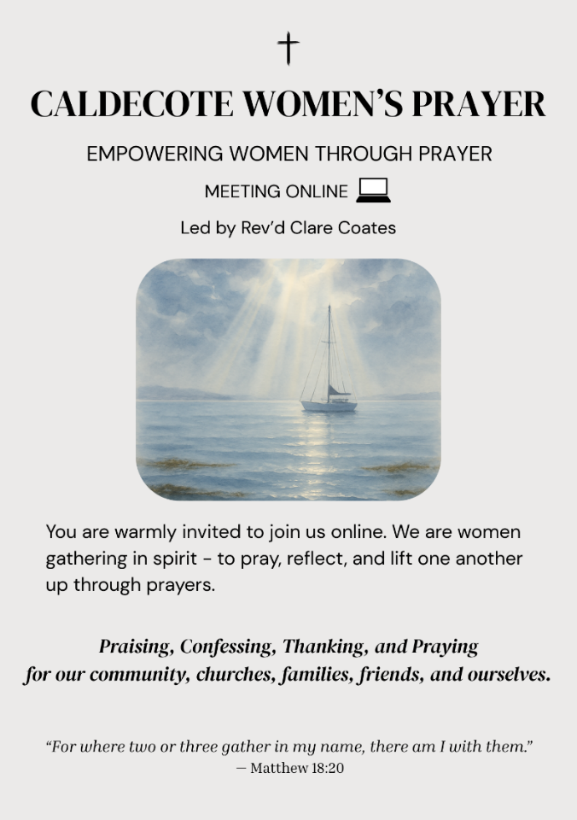
Caldecote Women’s Prayer group Thursday mornings in term time at 9am on Zoom Women from Caldecote and surrounding villages are warmly invited to join us online, gathering in spirit to pray, reflect and lift one another up through prayers. https://us02web.zoom.us/j/88137270141?pwd=pCvjk7eQrFqYX8GrvRP6JmMZKI9bYK.1
Meeting ID: 881 3727 0141
Passcode: 655934

What’s On:
Dry Drayton Coffee Morning
First Wednesdays every month, in the Village Hall, 10am -12noon.

Hardwick:
Tuesday Toddlers in the Cabin, every Tuesday in term time 10-11:30am.

All welcome to join us for free play, craft, story and fun!

Useful contacts
Assistant Minister:

Revd Sue Wyatt: sue.e.wyatt@btinternet.com
Lordsbridge Team:
Revd Claire Robertson, Lead Minister for Coton, Barton, Harlton and Haslingfield: 01223 874194; clairerobertson@lordsbridge.org
Revd Charles Fraser, Lead Minister for Little and Great Eversden: charlesfraser@lordsbridge.org; 01223 264974
Team Administrator: Mrs Sue Squire: thelordsbridgeteam@gmail.com
Lordsbridge Team Instagram: @lordsbridge_team
Lordsbridge Team Facebook Page: https://www.facebook.com/LordsbridgeTeam

