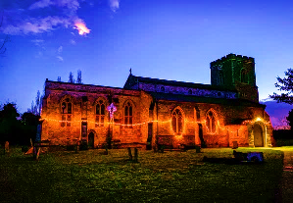
St Peter and St Paul’s Dry Drayton
A small church with a big heart

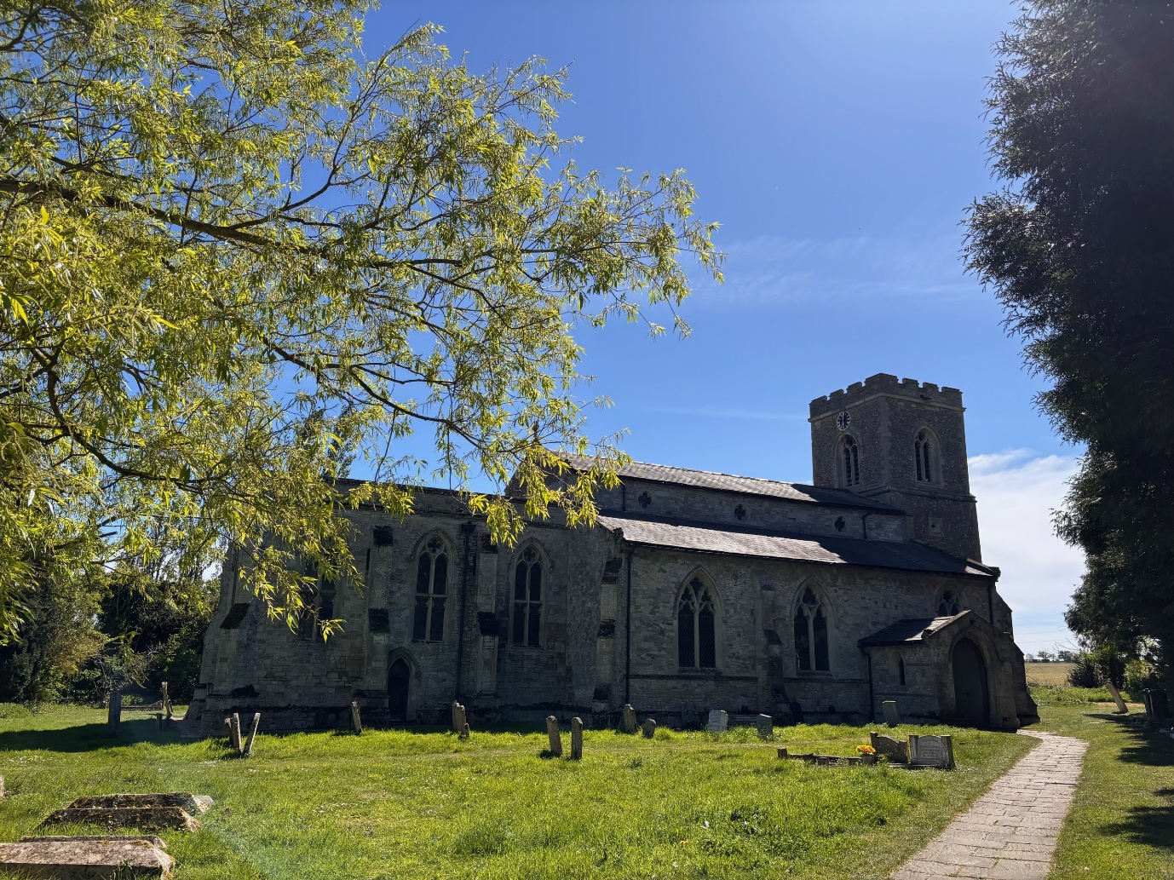
Newsletter May 2026
Dear Friends,
There is something incredibly spiritual about walking with friends – and making new ones along the way. Later in the month we will be embarking on our annual Lordsbridge Pilgrimage once more on Friday 22 May. This year we are trying something different. The walk has two routes – Northern (starting in Barton at 7:30am) and Southern (starting at 9:30am). Please see the poster below for more details. I will be joining the Northern route which crosses through Coton, Hardwick, Caldecote and Childerley before finishing in Dry Drayton. I am very much looking forward to visiting all these churches again, and to chatting with my fellow pilgrims enroute. Please do join us if you can, even if it’s just for a short stretch, or to welcome us home to Dry Drayton, where the Pilgrimage ends with lunch at approximately 2pm.
For Christians, going on pilgrimage involves a search for a deeper spirituality and for a closer connection to God. For the first time in modern history, our new Archbishop of Canterbury, Archbishop Sarah, completed an historic pilgrimage starting at St Paul’s Cathedral in London and walking 140km in 6 days to Canterbury. It was incredible to see so many people walking with her, greeting and meeting her enroute. Upon reaching Canterbury, Archbishop Sarah said: “It’s been a real joy; it’s also a joy to know we are done!” Pilgrimages are a great adventure, with the chance to meet new people and to see new places. To set aside time for God and feel closer to Him; to discern His will and guidance; and to be strengthened in faith. Going on pilgrimage can give us a new sense of awareness and wonder. Or result in a greater sense of our life’s purpose. Pilgrimage helps us to focus on ‘what really matters’ and to rediscover the joy of giving and generosity. I look forward to seeing you along the way!
God Bless,
Clare
Revd Clare Coates
Team Rector of the Lordsbridge Team
Lead Minister for Dry Drayton, Caldecote with Childerley and Hardwick
clarecoates@lordsbridge.org
07818 618 795
https://drydraytonchurch.co.uk/

Services in May 2026
Sunday 3 May
5:30pm Choral Evensong with Revd Clare.
Sunday 11 May
9:30am Holy Communion with Revd Clare
Thursday 14 May Ascension Day
7pm Lordsbridge Team Service at Harlton Church with Revd Clare and Sue Nelms preaching
Sunday 17 May
11am Morning Worship for all ages with Revd Clare.
Sunday 24 May
9:30am Holy Communion with Revd Canon Sue.
Sunday 31 May
10:30am Lordsbridge Team Fifth Sunday service church at Great Eversden Church with Revd Claire and Revd Clare preaching
Online Services

Sundays at 11am Lordsbridge Zoom Service
Join Zoom Meeting
https://us02web.zoom.us/j/88221400075?pwd=b3VQeDArQVJRREtYTlgrZ0tEbDdWdz09
Meeting ID: 882 2140 0075
Passcode: 534531

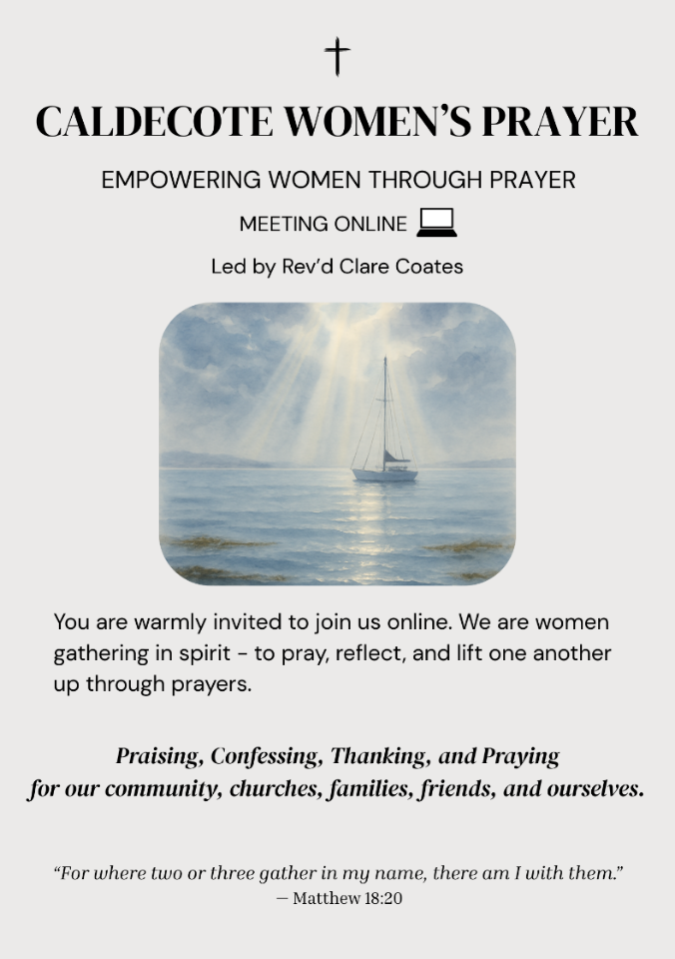
Caldecote Women’s Prayer group Thursday mornings in term time at 9am on Zoom Women from Caldecote and surrounding villages are warmly invited to join us online, gathering in spirit to pray, reflect and lift one another up through prayers. https://us02web.zoom.us/j/88137270141?pwd=pCvjk7eQrFqYX8GrvRP6JmMZKI9bYK.1
Meeting ID: 881 3727 0141
Passcode: 655934

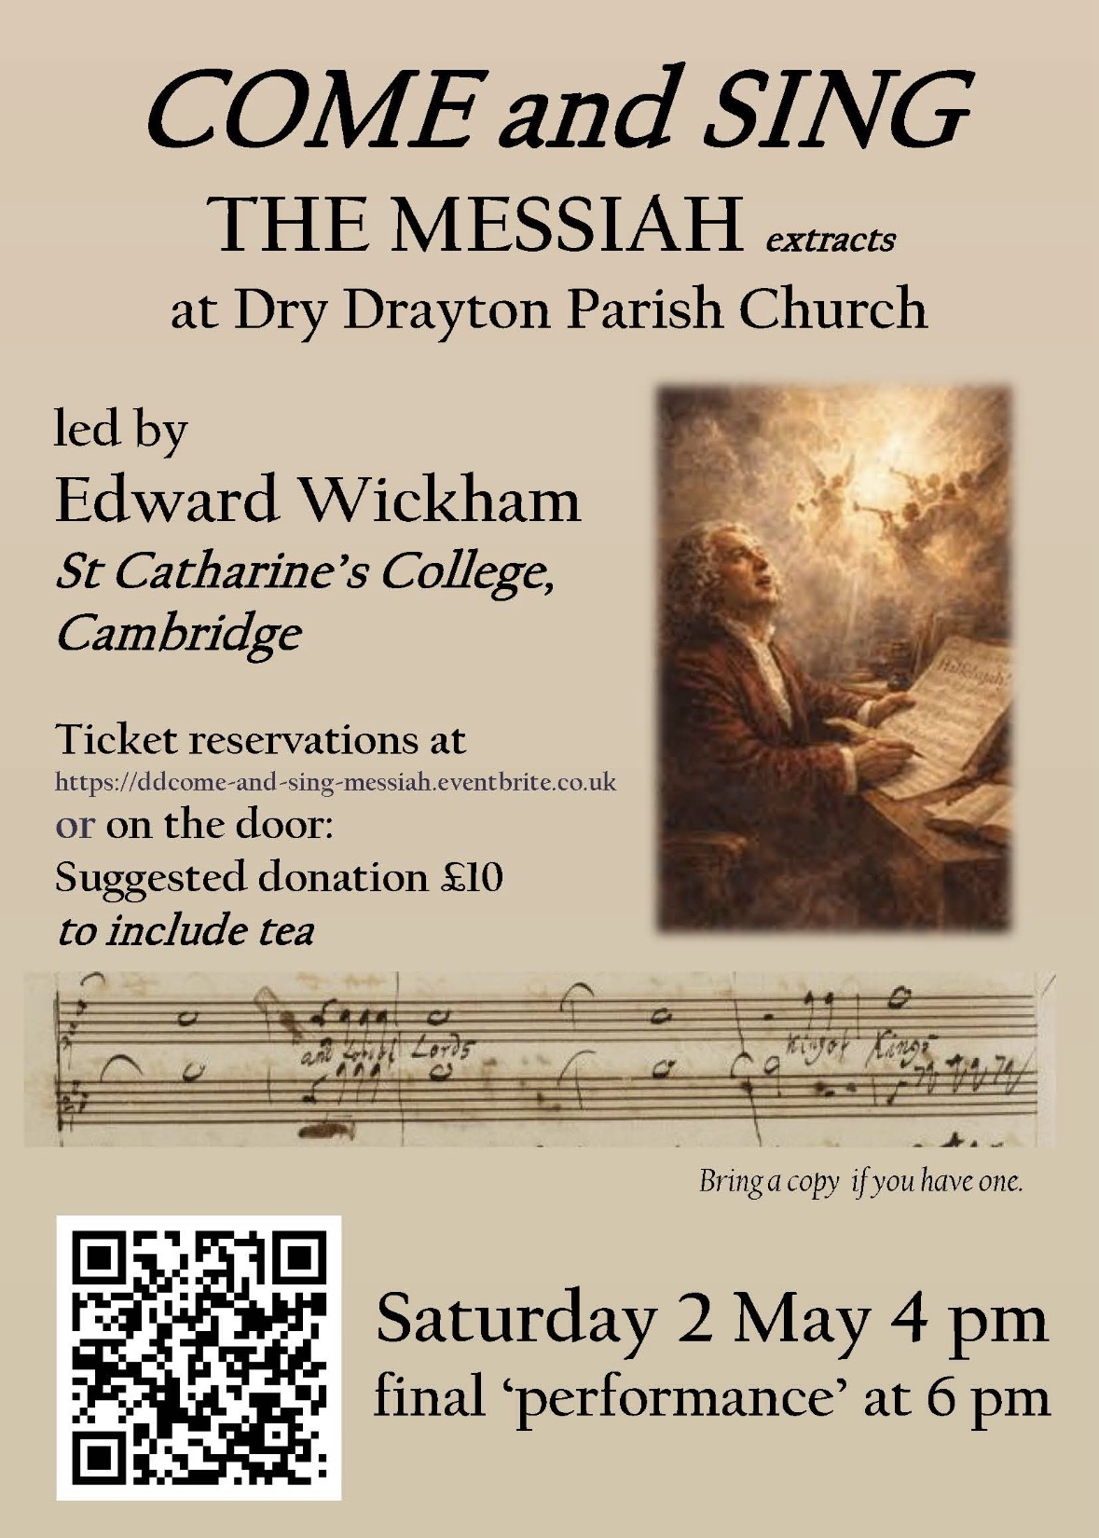




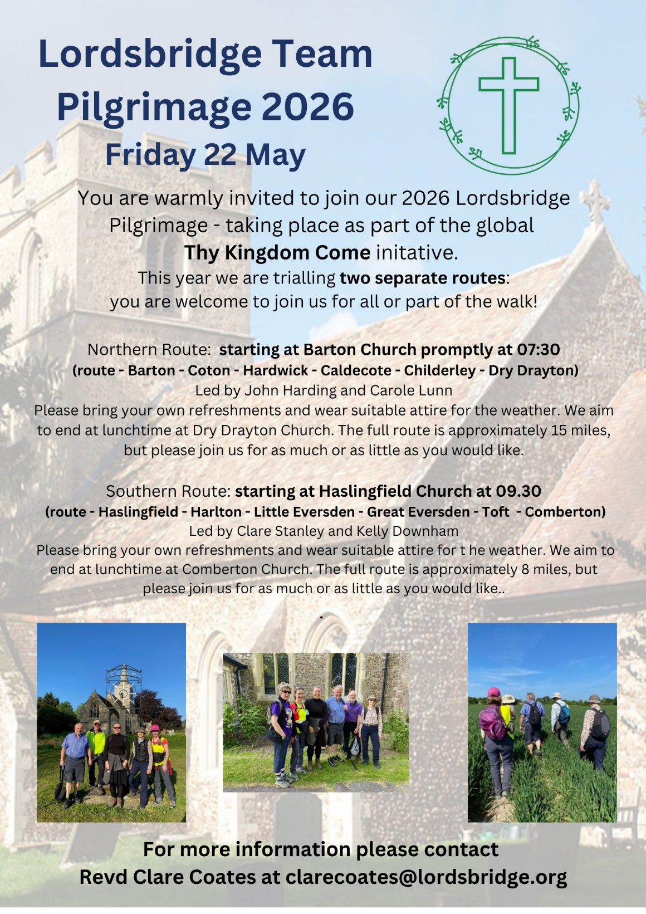
The Northern route:

Barton (leaving) 7:30am

Coton (leaving) 8:45am

Hardwick (leaving) 10am

Caldecote (leaving) 11:30am

Childerley (leaving) 1pm

Dry Drayton (arriving - for lunch!) c. 1:45pm

The Southern route:

Haslingfield (leaving) 9:30am

Harlton (leaving) 10:15am

Little Eversden (leaving) 11:am

Great Eversden (leaving) 11:30am

Toft (leaving) 12:30 pm

Comberton (arriving - for lunch!) c1:15pm

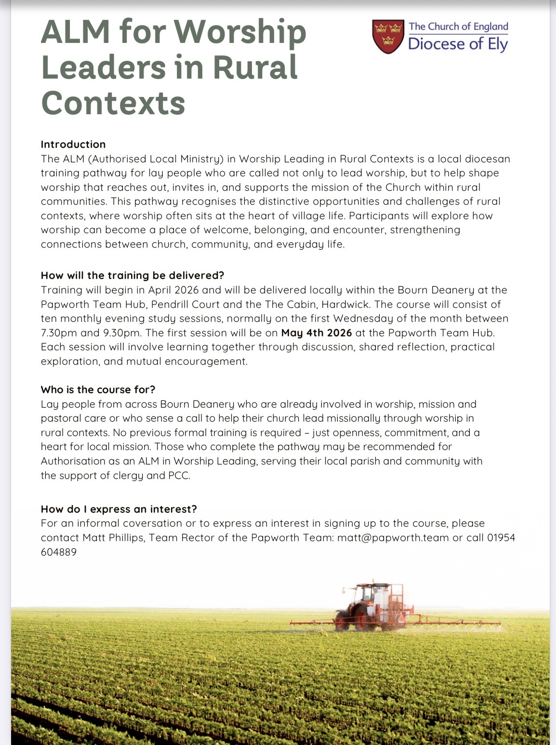
What’s On:
Dry Drayton Coffee Morning
First Wednesdays every month, in the Village Hall, 10am -12noon.

Hardwick:
Tuesday Toddlers in the Cabin, every Tuesday in term time 10-11:30am.

All welcome to join us for free play, craft, story and fun!

Useful contacts
Assistant Minister:

Revd Sue Wyatt: sue.e.wyatt@btinternet.com
Lordsbridge Team:
Revd Claire Robertson, Lead Minister for Coton, Barton, Harlton and Haslingfield: 01223 874194; clairerobertson@lordsbridge.org
Revd Charles Fraser, Lead Minister for Little and Great Eversden: charlesfraser@lordsbridge.org; 01223 264974
Team Administrator: Mrs Sue Squire: thelordsbridgeteam@gmail.com
Lordsbridge Team Instagram: @lordsbridge_team
Lordsbridge Team Facebook Page: https://www.facebook.com/LordsbridgeTeam

